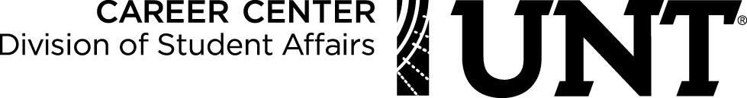

STUDENT EMPLOYEE PERFORMANCE EVALUATION

The purpose of the Student Employee Performance Evaluation is to facilitate communication between the student employee and their supervisor. It is designed to provide constructive feedback to the student employee on work performance and to assist with the development of learning goals and objectives. This form will be used at the midpoint of the student’s employment and at the end of a semester. It is recommended that both the student and the supervisor independently complete this evaluation and then discuss.

Please use the following scale to evaluate this employee's level of performance.
4 = Always Exceeds Standards 3 = Often Exceeds Standards
2 = Meets Standards 1 = Needs Improvement

Competency | Rating  Mid/Fin |  | Supervisor’s Comments
Job Knowledge: familiarity with job procedures and skills
Communication Skills: phone and in person with co-workers, supervisors, and clients
Quality/Quantity of Work: ability to do
satisfactory work following specific procedures in the time allowed
Initiative: interest in assuming additional responsibility
Judgment/Independence: ability to make sound decisions
Dependability: punctuality, notification of absences, flexibility
Attitude: enthusiasm, energy, willingness to work, relationship with others
Teamwork: ability to work with supervisors and co-workers
Leadership: ability to understand and direct others in a respectful manner
Continuous Improvement: ability to respond to feedback and make improvements
Customer Service degree of politeness and
friendliness shown to customers, co-workers and Career Center Staff.

Page 2

STUDENT EMPLOYEE PERFORMANCE EVALUATION

Goals & Objectives:

Supervisor Comments:

Student Comments:

Student Signature: Date:

Supervisor Signature: Date:

The student's signature confirms that the student has had the opportunity to read this evaluation. It does not necessarily reflect agreement. A copy of this evaluation should be given to the student.

